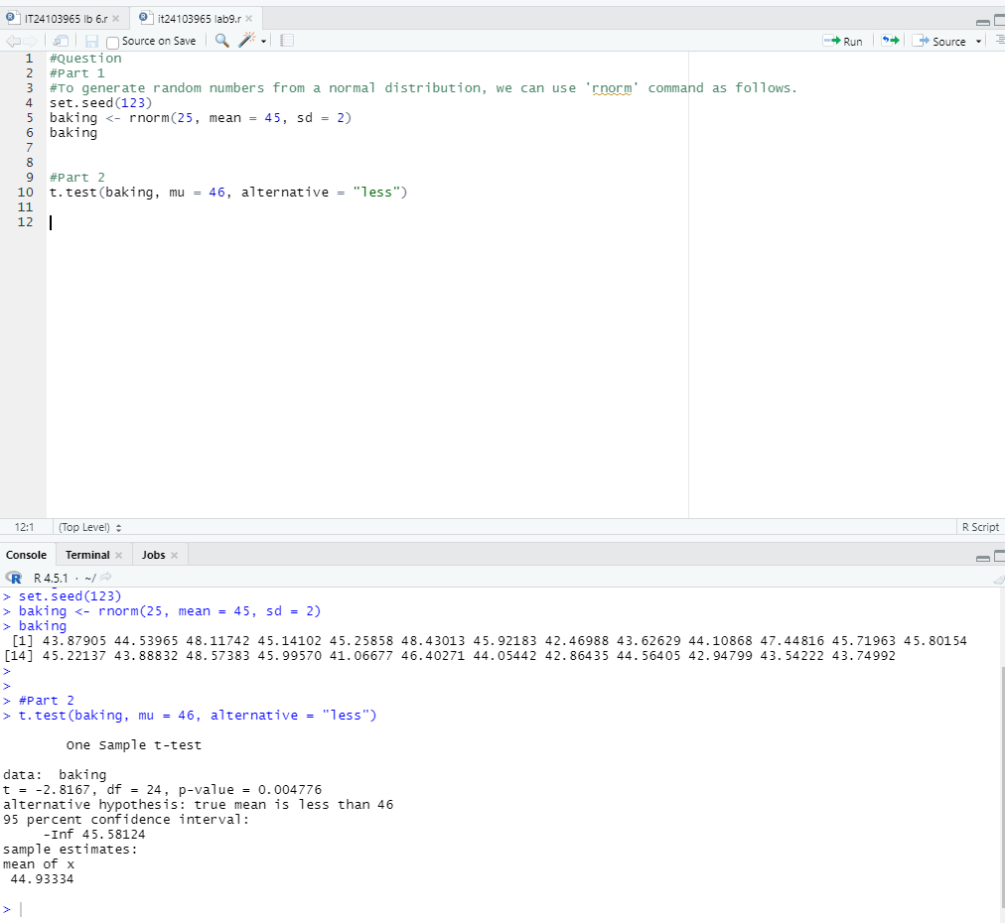S.Shruthihan IT24103965 Lab 09 PS